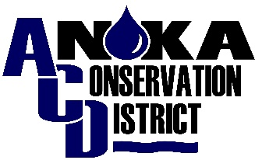
WELL SEALING
COST-SHARE APPLICATION
Version March 2024
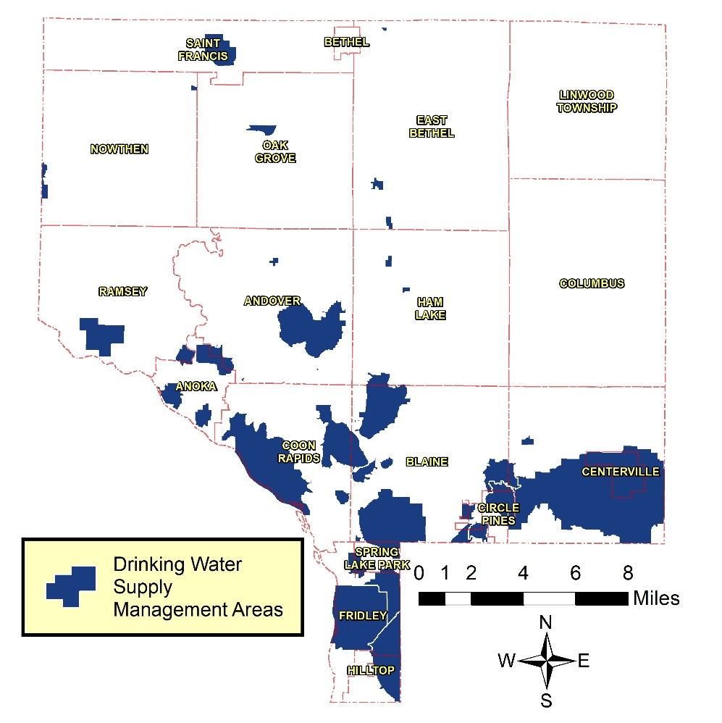
Program Purpose: In order to protect our drinking water from contamination, Anoka Conservation District (ACD) secured funds to aid Anoka County property owners in (see map to right) with the cost of professionally sealing wells that are not in use. Sealing unused wells prevents contaminants near the surface from entering drinking water supplies.

Post-Application Process:
Applications will be reviewed by ACD on a first-come-first serve basis.

Eligible applicants will be mailed a cost-share agreement from ACD about 2 - 6 weeks after ACD receives a complete application. This cost-share agreement will include items such as your final cost-share amount (60% of the lowest bid that ACD coordinated) and a list of items that must be submitted to ACD to verify project completion and contractor payment. The cost-share agreement must be signed by both ACD and the applicant, and be on-file at ACD’s office prior to proceeding with the well sealing project. ACD will NOT reimburse projects that were started prior to the signed cost-share agreement. Generally, applicants will have 90 days to request project reimbursement from the day that ACD received the signed cost-share agreement.

Well Sealing Cost-Share Eligibility Questions: To be eligible for cost-share, the permanent well sealing project must be located in both Anoka County.
- Are you seeking to protect drinking water by permanently sealing your well? ☐ Yes ☐ No
- Is your well located in Anoka County? ☐ Yes ☐ No
- Is your well located in a Drinking Water Supply Management Area? ☐ Yes ☐ No

See map above, or see MN Dept. of Health DWSMA Map Viewer for more detail www.health.state.mn.us/communities/environment/water/swp/mapviewer.html

Applicant Information:

Landowner Name________________________________________________________________

Mailing Address_________________________________________________________________

City _____________________________________ State _________ Zip ___________________

Well Address (if different) _________________________________________________________

Phone (home) ________________________________ (cell) ______________________________

Email__________________________________________________________________________
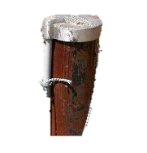
Well Information:
Year Original House was Built (approximate) __________________

Number of years’ house owned by current owner (approximate) __________________

Year well last used (approximate) __________________

Generally, where is the well located? ___________________________________________________
(e.g., in the front yard, in the basement under the front step, etc)

Is there anything that would prevent a crew from backing up to the well with a hoist truck?

__________________________________________________________________________________
(e.g., roof overhang, a fence, flower garden, trees, retaining wall, electrical lines, deck, etc.)
Attach the Following Photos to your Application:
- Looking down on the well, as if you’re standing on top of it. Include a tape measure in the photo that shows the diameter of the well.
- View of well from the side, showing the context of where the well is located
- Showing the access path to the well from the main road or driveway

If your well is located in your basement, also include photos of:
- The sidewalk or front step above the well (sometimes there’s a glass block above the well)
- Any obstruction(s), such as roof overhang, that might limit the use of a hoist truck to pull the well equipment through the basement access point.

Applicant Verification of Information:
I verify that the provided information is correct to the best of my knowledge. I understand that any private information, including contact information, is provided for the purposes of determining program eligibility; obtaining licensed well sealer project bids, and contacting applicants about the well sealing cost share program. I agree that typing my name and date in the signature constitutes a valid, binding electronic signature.

Landowner Signature _______________________________ Date __________________________

Submit complete application to:
Email (preferred) Mail

kris.larson@anokaswcd.org Or, Anoka Conservation District
1318 McKay Dr NE, Suite 300
Ham Lake MN, 55304

FOR ANOKA CONSERVATION DISTRICT USE ONLY:
Funding Provided Through
Application Received ____________________ ID Code¹ ______________________
Application Status: ☐ Approved ☐ Incomplete Application
☐ Ineligible _______________________________________________
Staff Signature ________________________________ Date _______________________
Notes _______________________________________________________________________

